Excel configuration file

Specification document

This document describes the technical specification of the Excel configuration file, which is used as input to the Python-based computational kernel.

# Spreadsheet layout

The input to a computational kernel must be exact and valid. A user can construct a configuration in Excel in accordance with the template, described in this section, which is the basis of said input. This configuration is processed by a parser to produce an equivalent in the computational kernel’s data format – the ‘exact’ aspect. As a subsequent step, the parsed configuration is inspected and tested for validity. Both parsing and validation attempt to be as strict and comprehensive as possible, to prevent the computational kernel from calculating a scenario which is not identical to what the user intended.

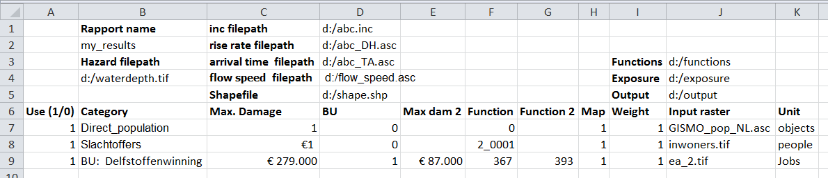

Figure 1: Example of an Excel configuration file.

An example configuration file is used to illustrate the Excel template, see figure 1. First, the fixed elements – show in bold – are defined. After that the content and meaning of the associated cells are explained. The Excel template is based on the following formatting rules:

* All information is typed in the first sheet. All other sheets are ignored.
* Cells B1, B3, C1, C2, C3, C4, C5, I3, I4, I5, A6, B6, C6, D6, E6, F6, G6, H6, I6, J6 and K6 are used as absolute positions, to which user defined cells have a relative position.
  + These locations are hardcoded in the parser and cannot be changed by the user.
  + The actual string content of these cells serve as a convenience to the user, and is ignored by the parser.
* Cells B2, B4, D1, D2, D3, D5, J3, J4 and J5 contain one word each.
  + The used characters must be legal in the context of a filepath.
  + Windows’ path separators must be escaped: “\\”, not “\”.
* Cell E1 can contain an integer.
* The cells under cells A6, D6 and H6 contain a one (“1”) or a zero (“0”).
* The cells under cells B6 and K6 contain one or more words.
* The cells under cell J6 contain one word.
  + The used characters must be legal in the context of a filepath.
  + Windows’ path separators must be escaped: “\\”, not “\”.
* The first empty cell under cell A6 indicates the end of the file. All subsequent lines are ignored.

A user can supply the following information through the Excel file:

* Cell B2 contains the name of the rapport file. It is specified without a file extension. The file will be created in the output folder (see cell J5).
* Cell B4 contains the absolute filepath of the waterdepth file (hazard).
* (**optional**) Cell D1 contains the absolute filepath of the incremental file, being an inc-file. It excludes the use of cells D2 and D3.
* (**optional**) Cell D2 contains the absolute filepath of the rise rate file, being a grid file. It excludes the use of cell D1.
* (**optional**) Cell D3 contains the absolute filepath of the arrival time file, being a grid file. It excludes the use of cell D1 and requires cell D2 to be specified.
* (**optional**) Cell D4 contains the absolute filepath of the flow speed file, being a grid file.
* (**optional**) Cell D5 contains the absolute filepath of the shape file, which will be used for all categories.
* (**optional**) Cell E1 contains the offset on t0, to be used when reading the incremental file.
* Cell J3 contains the absolute filepath of the directory containing the damage functions.
* Cell J4 contains the absolute filepath of the directory containing the category grids (exposure).
* Cell J5 contains the absolute filepath of the output directory.
* The cells under cell A6 specify whether their line should be used (1) or ignored (0).
* The cells under cell B6 specify the name of a category.
* The cells under cell C6 and E6 specify the maximum damage in Euro, as used by the damage functions.
* The cells under cell D6 specify whether both (1) or only the first (0) damage function is to be used.
* The cells under cells F6 and G6 specify the name of a damage function file, without the file extension, nor the containing directory. They are assumed to be located in the folder “Functions”, located at the same level as the category grids (see cell J4).
* The cells under cell H6 specify whether a damage grid is to be output for this category.
* The cells under cell I6 specify an overall weight factor, which scales the damage.
* The cells under cell J6 specify the category grid file name, with or without file extension.
  + The default extension is “.asc”.
* The cells under cell K6 specify the units of the category.